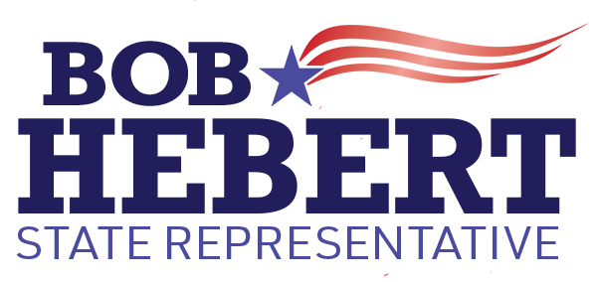

Dear Friends,
Protecting our children and ensuring a solid education are among our most sacred responsibilities.
I stand with parents and proudly signed the Parental Pledge in which I promise to honor the fundamental rights of parents including the right to direct the education, medical care and moral upbringings of their children. I pledge to advance policies that strengthen parental involvement, increase transparency and push back against government overreach.
As your state representative, I will be a common-sense advocate for our children and their academic achievement. I will work to increase support services to address learning loss and mental health struggles, strengthen the focus on core curricula, increase the number of School Resource Officers to ensure a safe learning environment and ensure we reinstate Special Ed funding so that we don’t have to take funds away from other departments (our current State Rep voted to cut the Special Education budget by $228,939 in 2021-2022 with another expected $300,000 in cuts in 2022-2023).
In addition to this, I will also fight for local control of our schools which are under direct threat from Hartford. SB 1202, which recently passed, has given Hartford the power to dictate a required reading curriculum for all 169 towns including Ridgefield. This means our schools will need to apply for a waiver or be forced to replace the current reading program they spent approximately $250,000 and two years developing with an off-the-shelf one size fits all program.
This is not acceptable. Our kids deserve better. We need to push back and demand autonomy over our schools and curriculum. You have my promise, I will be a fierce advocate for our kids and our schools.

My door is always open. Please reach out directly should you have any questions or concerns at bob@bobforstaterep.com or via my website www.BobForStateRep.com.

Together, we can make a difference!

Thank you,
Bob
Bob Hebert for State Representative

